7.42: a) Equating the potential energy stored in the spring to the block's kinetic energy, 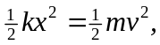 or
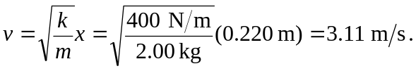
b) Using energy methods directly, the initial potential energy of the spring is the final gravitational potential energy, 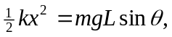 or
